Project Design Phase-II
Data Flow Diagram & User Stories

Date | 01-02-2026
Team ID | LTVIP2026TMIDS73327
Project Name | AutoSage App Using Gemini Flash
Maximum Marks | 4 Marks

Data Flow Diagrams:
A Data Flow Diagram (DFD) illustrates how data moves within the Freelance Finder platform. It captures how users (freelancers and clients) interact with the system, how information flows between different components, and where the data is stored.

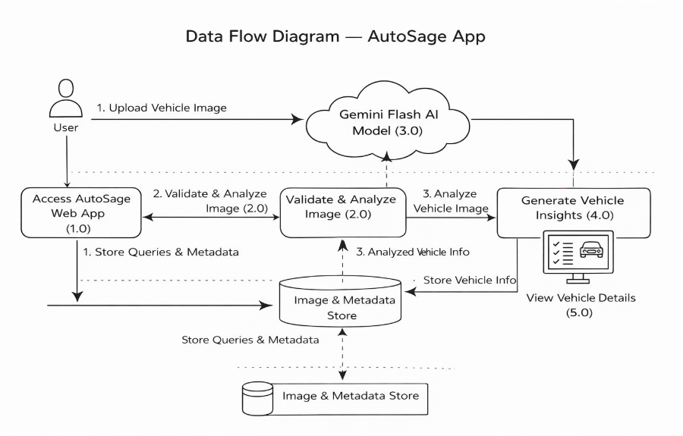
BOOK NEST
MERN STACK SYSTEM

User Story Table – AutoSage App
User Type | Functional Requirement (Epic) | User Story / Task | Acceptance Criteria | Priority | Release
User | App Access | As a user, I can open the AutoSage web application. | Application loads successfully. | High | Sprint-1
User | Image Upload | As a user, I can upload a vehicle image. | Image uploads without errors. | High | Sprint-1
User | Image Validation | As a user, I want only valid images to be accepted. | Invalid formats are rejected. | High | Sprint-1
User | AI Analysis | As a user, I want the system to analyze my vehicle image using AI. | Image is processed successfully. | High | Sprint-1
User | Vehicle Identification | As a user, I want to know the vehicle brand and model. | Correct brand and model are displayed. | High | Sprint-1
User | Vehicle Details | As a user, I want to see mileage and price details. | Vehicle details are shown clearly. | High | Sprint-1
User | Resale Information | As a user, I want to view resale value estimates. | Resale value is displayed. | Medium | Sprint-2
User | AI Summary | As a user, I want a short AI-generated summary. | Summary is concise and readable. | Medium | Sprint-2
User | Error Handling | As a user, I want clear messages for errors. | Error messages are shown properly. | Medium | Sprint-2
Admin | System Monitoring | As an admin, I want to monitor system activity. | Logs are recorded successfully. | Low | Sprint-2

